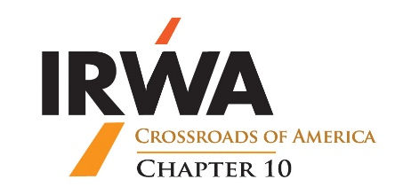
2025 Chapter 10 Young Professional of the Year
Nomination Form

Description: The IRWA Chapter 10 Young Professional of the Year award recognizes a young professional in the right-of-way industry. This award honors an individual who has demonstrated exemplary support for the Chapter and has positively impacted the Chapter through leadership, educational courses, professional advancement, active participation in the Chapter, and/or recruitment of other young professionals at the Chapter level.

Requirements:
Nominee 35 years of age or younger or who has been in the right-of-way industry for less than two years.
The nominee must reside and work in Indiana.
The nominee must be a Chapter 10 member.
This completed nomination form must be received by: 11/07/2025 at 12:00 PM ET.

Nominee’s Name: ______________________________________________

Nominee’s Employer’s Name: ___________________________________

Date of birth and/or years in the right-of-way industry: __________

Years as a Chapter 10 member: _______________________________

How do you know the nominee, and how long have you known the nominee?

_____________________________________________________________________________________
_____________________________________________________________________________________
Please explain why the nominee should be considered for this award and include information about the nominee in the categories below, if applicable, during the past year. The list below is not exhaustive, and information about the nominee in every category is not required for the nominee to be considered for the award.

IRWA and other professional designations and/or candidacies, Professional licenses, educational degrees, IRWA (International, Regional and Chapter 10) offices held,
IRWA professional development assistance with organizing, presentation and attendance with meetings, attendance at and participation in IRWA conferences, meetings and events, contributions to IRWA and other industry or professional publications, recruitment efforts of other young professionals for the Chapter, examples of leadership within the Chapter, IRWA sponsorships and other financial and in-kind contributions and support:
_______________________________________________________________________________________________________________________________________________________________________________________________________________________________________________________________
_______________________________________________________________________________________________________________________________________________________________________________________________________________________________________________________________
_______________________________________________________________________________________________________________________________________________________________________________________________________________________________________________________________

Please provide any other information about the nominee’s accomplishments and/or participation in IRWA-related activities, which you believe is significant. _______________________________________________________________________________________________________________________________________________________________________________________________________________________________________________________________
Nominated By: ______________________________________________________

Nominator’s Company, Firm or Agency: ______________________________

Nominator’s Telephone No. ___________________________________________

Nominator’s Email Address: ___________________________________________

________________________________________ Date: ____________________
Signature of Nominator

