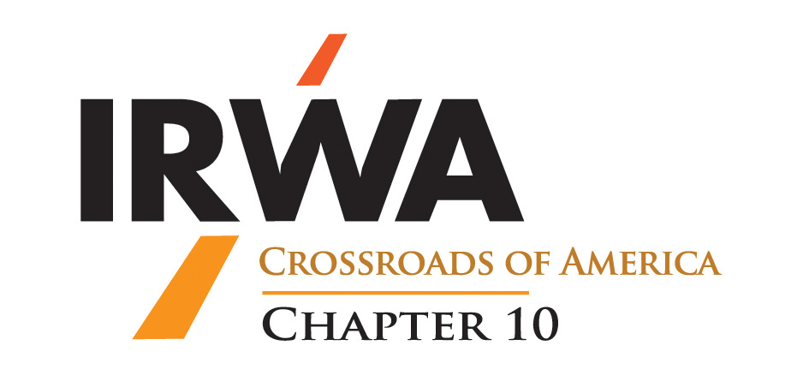

Chapter 10 Project of the Year
Nomination Form

Project Name: ___________________________________

Project Location: _________________________________

Project Owner: __________________________________

Right of Way Services Firm: _________________________

Right of Way Project Manager: _______________________

Project Sponsor: ___________________________________

Project Right of Way Completion Date: _________________

Complete and email to Patrick McCallister at Patrick.McCallister@wsp.com.

IRWA Chapter 10 Project of the Year Criteria
- Must be a project in Indiana
- Must be completed (right of way clear for construction) in calendar year of nomination
- Nomination sponsor must be a Chapter 10 Member and a Key Member of Project Team
- Nomination must be received by November 1st of the year of nomination and contain the following information.
- Project Description
- Owner of Project
- Project Manager for Right of Way Services
- Key Members of Project Team
- Narrative of why project is worthy of award (provided on second page)

- Awards will be given at the Annual Christmas Party/Awards Banquet to the following:
- Owner of Project
- Project Manager for Right of Way Services.

Project Narrative:

