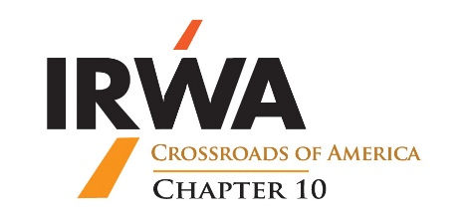
2025 Chapter 10 Professional of the Year
Nomination Form

Description: The IRWA Chapter 10 Professional of the Year recognizes a right-of-way industry professional who has contributed to the advancement of the right-of-way profession. This award honors an individual who has demonstrated exemplary support to the Chapter and has positively impacted the Chapter through leadership, educational courses, professional advancement and/or active participation in the Chapter.

Requirements:
The nominee must reside and work in Indiana.
The nominee must be a Chapter 10 member.
This completed nomination form must be received by: 11/07/2025 at 12:00 PM ET.

Nominee’s Name: ______________________________________________

Nominee’s Employer’s Name: ___________________________________

Years in the right-of-way industry: ______________________________

Please explain how you are acquainted with the nominee. _______________________________________________________________________________________________________________________________________________________________________________________________________________________________________________________________

Please explain why the nominee should be considered for this award and include information about the nominee in the categories below, if applicable, during the past year. The list below is not exhaustive, and information about the nominee in every category is not required for the nominee to be considered for the award.

IRWA and other professional designations and/or candidacies, Professional licenses, educational degrees, IRWA (International, Regional and Chapter 10) offices held, IRWA professional development assistance with organizing, presentation and attendance, attendance at and participation in IRWA conferences, meetings and events, as well as contributions to IRWA and other industry or professional publications, IRWA sponsorships and other financial and in-kind contributions and support:
_____________________________________________________________________________________________________________________________________________________________________________________________________________________________________________________________________________________________________________________________________________________________________________________________________________________________________________________________________________________________________________________________________________________________________________________________________________________________________________________________________________________________________________________________________________________________________________________________
__________________________________________________________________________________________________________________________________________________________________________
__________________________________________________________________________________________________________________________________________________________________________
__________________________________________________________________________________________________________________________________________________________________________

Please provide any other information about the nominee’s accomplishments and/or participation in IRWA-related activities, which you believe is significant. _______________________________________________________________________________________________________________________________________________________________________________________________________________________________________________________________

Nominated By: _______________________________________________________

Nominator’s Company, Firm or Agency: _______________________________

Nominator’s Telephone No. ___________________________________________

Nominator’s Email Address: ____________________________________________

________________________________________ Date: ____________________
Signature of Nominator

